Sample Report

Kelompok 3

-Subkhan Ibnu Aji (1301172001)

-Ahmad Refi Juliano (1301174040)

-Novelly Naomi Lingga (1301173407)

-Muhammad Alkahfi Khuzaimy Abdullah (1301174048)

**10 MK Pilihan terfavorit**

*Query* :

select mk_id, nama, sks, jenis, count (mk_id) as jumlah_diambil

from mengambil join matkul using (mk_id)

where jenis = ‘Pilihan’

Group by mengambil.mk_id, matkul.nama, matkul.sks, matkul.jenis

order by count(mk_id) desc

limit 10;

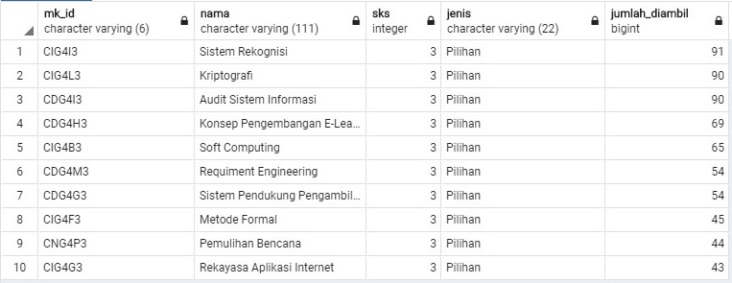

**5 MK Wajib dengan tingkat kelulusan terendah**

*Query :*

select mk_id, nama, sks, jenis, count(nilai) as jumlah_tidak_lulus

from mengambil join matkul using(mk_id)

where jenis = ‘Wajib’ and nilai = ‘E’

group by mengambil.mk_id, matkul.nama, matkul.sks, matkul.jenis

order by count(nilai) desc

limit 5;

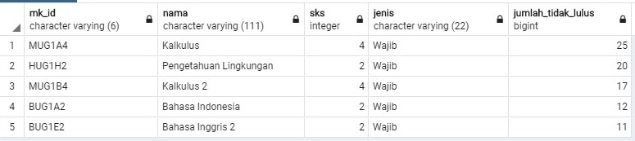

**10 Mahasiswa dengan IPK tertinggi**

*Query:*

select nim, nama, kelas_asal, count(nilai) as jml_nilai_A

from mengambil join mahasiswa using (nim) where nilai = ‘A’

group by nim, nama, kelas_asal order by count(nilai) desc limit 10;

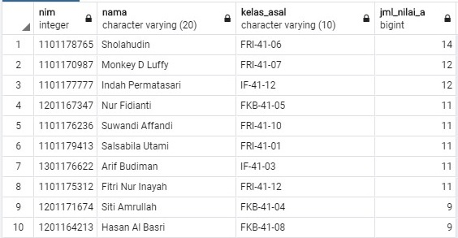

**Filterby Program Studi**

**Mahasiswa IF**

*Query:*

select * from mahasiswa where cast(nim AS TEXT) like '13%';

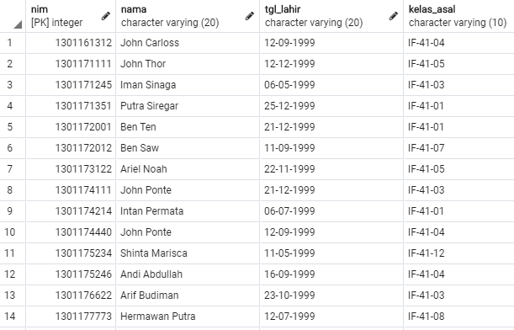

**Mahasiswa FKB**

*Query:*

select * from mahasiswa where cast(nim as text) like '12%';

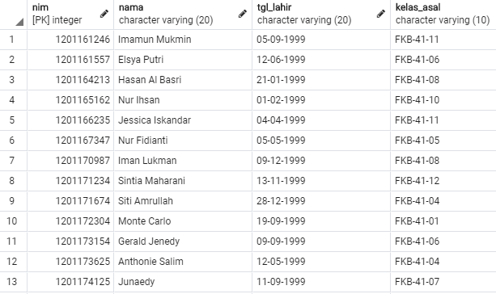

**Mahasiswa FRI**

*Query:*

select * from mahasiswa where cast(nim as text) like '11%';

